Appendix – The Mathematics behind the Neural Network

BCSAI
Y1-Q1
Principles of Programming

Index
1- Introduction
1.1- Forward propagation
1.2- Backward propagation

Introduction
Neural networks are a class of biomimetic technology inspired by biological intelligence. In a mathematical sense, neural networks are vector-valued functions that transform inputs through non-linear weighted sums. The elemental unit of neural networks are neurons. Each layer of the network is composed of a fixed number of neurons.
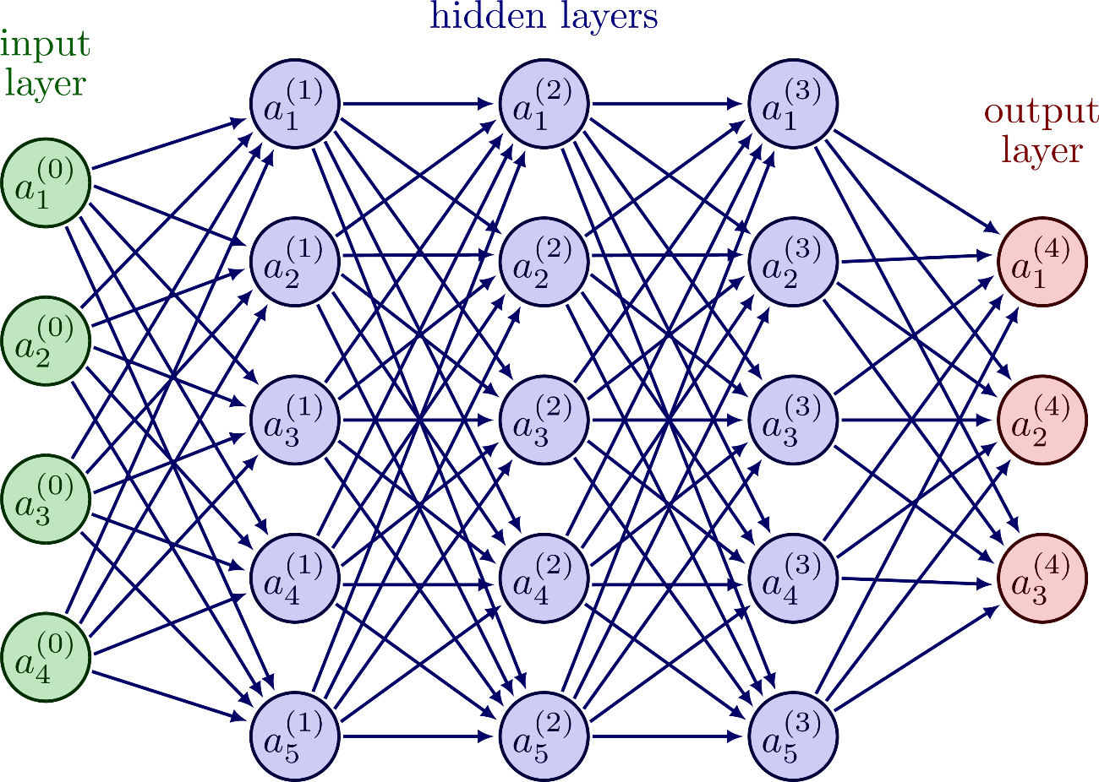
Figure 1
The value of each neuron $a_{i}^{[l]}$ in layer l, is given by the image of a non-linear function to the weighted sum of the value of all previous neurons $a_{j}^{[l-1]}$ plus a bias term $b_{i}^{[l]}$.
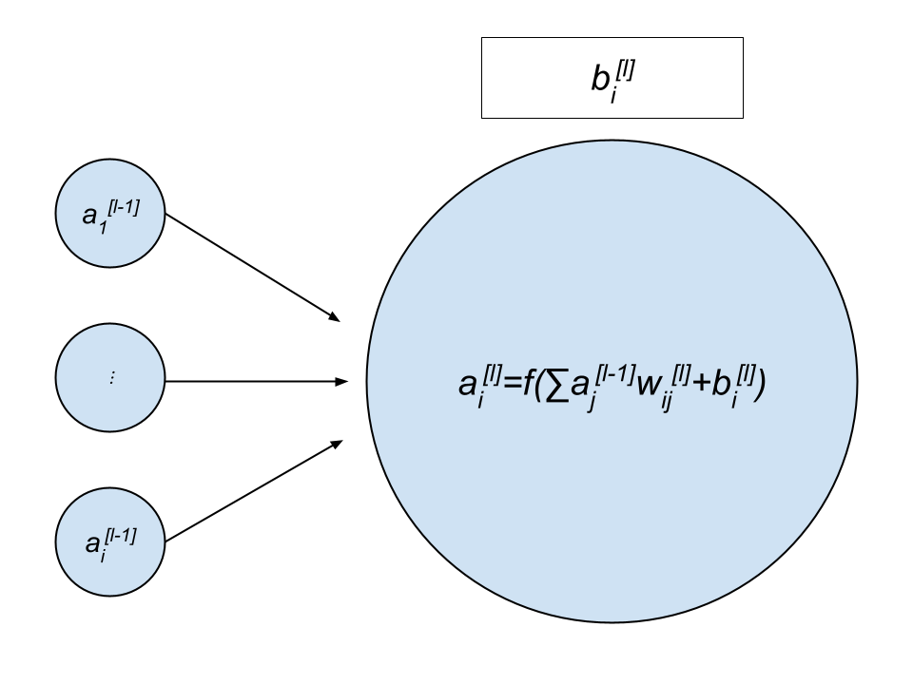
Figure 2

Forward propagation
The process of calculating the value of the neurons in each layer up until the output layer is known as forward propagation. The process of propagating one layer onto the next can be summarized in a single matrix multiplication:
$$\left[\begin{matrix}a_{0}^{[l]} \\ ⋮ \\ a_{i}^{[l]}\end{matrix}\right]=f\left(\left[\begin{matrix}w_{00}^{\left[l\right]} & ⋯ & w_{1j}^{\left[l\right]} \\ ⋮ & ⋱ & ⋮ \\ w_{i0}^{\left[l\right]} & ⋯ & w_{jj}^{\left[l\right]}\end{matrix}\right]\left[\begin{matrix}a_{0}^{[l-1]} \\ ⋮ \\ a_{j}^{[l-1]}\end{matrix}\right]+\left[\begin{matrix}b_{0}^{[l]} \\ ⋮ \\ b_{i}^{[l]}\end{matrix}\right]\right)$$
Such that $W^{[l]}$ is the weight matrix containing all different weights $w_{ij}^{[l]}$: the weight connecting a neuron i in layer l, with the neuron j in the previous layer l-1.
The prediction a neural network makes is typically identified as the neuron which – analogous to brain function – lights up the most, that is, the neuron with highest value. Each neuron in the output layer maps injectively to a possible prediction value. For example, if a neural network were predicting a hand-written digit from 0-9, there would be 10 output neurons: neuron $a_{0}^{\left[L\right]}$ maps to 0, $a_{1}^{\left[L\right]}$ to 1 and so on.

Backward propagation
For the model to make accurate predictions, the weights and biases of each layer must be optimized such that some error function is minimized. The error function, usually referred to as cost function $J$, measures error through some form of difference between the predicted and true value: for instance, mean square error. For one training example on which the model is trained, the cost is:
$$J_{k}\left(W, b\right)=\frac{1}{n}\sum_{i}^{n}{{\left(a_{i}^{\left[L\right]}- y_{i}\right)}^{2}}$$
The cost over all training examples is taken to be the average cost of all training examples:
$$J\left(W, b\right)=\frac{1}{m}\sum_{k}^{m}{J_{k}\left(W, b\right)}$$
The cost function is defined as function from all weights and biases across all layers, to the cost.
$$J:R^{n}→R$$
Although its unfeasible to analytically determine the values of all weight and biases $W, b$ that minimize $J$. A local minimum can be determined through gradient descent.
The method of gradient descent involves discretely advancing in the direction opposite to the direction of greatest ascent as determined by the gradient vector $∇J$. Eventually, after a number of descends one would arrive at a local minimum – which may not be the global minimum.

The weights and biases are therefore updated as follows:

$$θ←\left(\begin{matrix}W_{00}^{\left[0\right]} \\ ⋮ \\ W_{ij}^{\left[0\right]} \\ b_{0}^{\left[0\right]} \\ ⋮ \\ b_{i}^{\left[0\right]} \\ ⋮ \\ W_{00}^{\left[l\right]} \\ ⋮ \\ W_{ij}^{\left[l\right]} \\ b_{0}^{\left[l\right]} \\ ⋮ \\ b_{i}^{\left[l\right]}\end{matrix}\right)-α\left(\begin{matrix}\frac{∂J}{∂w_{00}^{[0]}} \\ ⋮ \\ \frac{∂J}{∂w_{ij}^{[0]}} \\ \frac{∂J}{∂b_{0}^{[0]}} \\ ⋮ \\ \frac{∂J}{∂b_{i}^{[0]}} \\ ⋮ \\ \frac{∂J}{∂w_{00}^{[L]}} \\ ⋮ \\ \frac{∂J}{∂w_{ij}^{[L]}} \\ \frac{∂J}{∂b_{0}^{[L]}} \\ ⋮ \\ \frac{∂J}{∂b_{i}^{[l]}}\end{matrix}\right)=θ- α∇J$$
Determining the partial derivatives of the cost function respect to each weight and bias $\frac{∂J}{∂w_{ij}^{[l]}}$, $\frac{∂J}{∂b_{i}^{[l]}}$ requires of an algorithm known as backpropagation.
The aforementioned partial derivatives can be expressed as follows by the chain rule:
$$\frac{∂J_{k}}{∂w_{ij}^{[l]}}=\frac{∂z_{i}^{[l]}}{∂w_{ij}^{[l]}}\frac{∂a_{i}^{[l]}}{∂z_{i}^{[l]}}\frac{∂J_{k}}{∂a_{i}^{[l]}}=a_{j}^{\left[l-1\right]}σ'(z_{i}^{[l]})\frac{∂J_{k}}{∂a_{i}^{[l]}}$$
$$\frac{∂J_{k}}{∂b_{i}^{[l]}}=\frac{∂z_{i}^{[l]}}{∂b_{i}^{[l]}}\frac{∂a_{i}^{[l]}}{∂z_{i}^{[l]}}\frac{∂J_{k}}{∂a_{i}^{[l]}}=\frac{∂a_{i}^{[l]}}{∂z_{i}^{[l]}}\frac{∂J_{k}}{∂a_{i}^{[l]}}=σ'(z_{i}^{[l]})\frac{∂J_{k}}{∂a_{i}^{[l]}}$$
In the case of the output layer $l=L$:
$$\frac{∂J_{k}}{∂a_{i}^{\left[l\right]}}=\frac{2}{n}\left(a_{i}^{\left[L\right]}-y_{i}\right)$$
However, for other layers $l$, determining $\frac{∂J_{k}}{∂a_{i}^{\left[l\right]}}$ involves calculating the effect $a_{i}^{\left[l\right]}$ has on all neurons in the following layer:
$$\frac{∂J_{k}}{∂a_{j}^{\left[l\right]}}=\sum_{i=0}^{n}{\frac{∂z_{i}^{\left[l+1\right]}}{∂a_{j}^{\left[l\right]}}\frac{∂a_{i}^{[l+1]}}{∂z_{i}^{\left[l+1\right]}}\frac{∂J_{k}}{∂a_{i}^{\left[l+1\right]}}}=w_{ij}^{[l+1]}σ'\left(z_{i}^{\left[l+1\right]}\right)\frac{∂J_{k}}{∂a_{i}^{\left[l+1\right]}}$$
This partial derivative requires knowing $\frac{∂J_{k}}{∂a_{i}^{\left[l+1\right]}}$.
Therefore, the term $\frac{∂J_{k}}{∂a_{j}^{\left[l\right]}}$ obliges one to begin calculating the partial derivatives of the cost function with respect to the weights and biases from the last layer. Then the results from the output layer can be used to determine the results of the previous layer and so on. Given the backwards and iterative nature of this process, the algorithm is referred to as backpropagation as opposed to the previous step: forward propagation.
The process of backpropagation can be expressed in the following matrix operations:
Base case:
$$δ^{\left[L\right]}=\frac{2}{n}\left(A^{\left[L\right]}-Y\right)⊙σ^{'}\left(Z^{\left[L\right]}\right)$$Backpropagating terms:
$$δ^{\left[l\right]}=\left(W^{\left[l+1\right]T}δ^{\left[l+1\right]}\right)⊙σ^{'}\left(Z^{\left[l\right]}\right) \\ \frac{∂J}{∂W^{\left[l\right]}}=δ^{\left[l\right]}A^{\left[l-1\right]T} \\ \frac{∂J}{∂B^{\left[l\right]}}=δ^{\left[l\right]}$$

